The purpose of this report is to analyze the discussions and trends surrounding the STEM PUSH Network, as well as associated keywords, across social media platforms and external websites.

This research aims to provide valuable insights into the perceptions, reactions, and engagement of the public with regards to the STEM PUSH Network and its affiliated initiatives. By examining posts, comments, and interactions on popular platforms such as Twitter, LinkedIn, and Instagram, we seek to understand the level of awareness, support, and potential concerns among various stakeholders. Furthermore, we explore external websites to gather pertinent information and news articles that illuminate the broader impact of STEM education and related funding initiatives.

**Methodology**

The objective of this research project is to analyze the discussions and reactions related to the STEM PUSH (Pathways for Underrepresented Students to Higher Education) network. To achieve this objective, the team identified specific keywords to search for in popular social media platforms such as Twitter, Instagram, and LinkedIn.

The following keywords have been identified to conduct searches on above social media websites to identify relevant posts:

* STEM PUSH
* STEM PUSH (Pathways for Underrepresented Students to Higher Education) Network
* STEM PUSH Alliance
* STEM PUSH Network
* STEM PUSH Network Hub
* STEM PUSH Network Alliance
* STEM PUSH Network, University of Pittsburgh
* STEM PUSH Alliance, University of Pittsburgh
* NSF INCLUDES Alliance 1930990: The STEM PUSH Network
* NSF INCLUDES Alliance 1930990
* Pathways for Underrepresented Students to Higher Education
* Pre College STEM Programs (PCSPs)

To gather data from these platforms, the team initially considered using [web scraping](https://en.wikipedia.org/wiki/Web_scraping) techniques with libraries like Beautiful Soup in Python. However, it was discovered that the social media platforms employed [Infinite Scrolling](https://evgeniiray.medium.com/infinite-scrolling-in-web-ultimate-guide-b698124b3172), a technique where new data gets loaded by scrolling the page, making it necessary to switch to [Selenium](https://www.selenium.dev/), a web automation tool, to navigate and retrieve data from these dynamic pages.

Three separate Excel workbooks were prepared, one each for LinkedIn, Instagram, and Twitter, to organize and store the collected data. Each workbook contained multiple worksheets corresponding to the identified keywords, allowing for a systematic categorization of the gathered information.

For Twitter, the team leveraged the advanced search functionality provided by the platform's search engine. This allowed for the extraction of tweets containing the exact information related to the STEM PUSH network. The data collected from Twitter included the author of the post, the post description, the hashtags used, and the number of reposts, likes and comments.

Similarly, for LinkedIn and Instagram, the team used Selenium to automate the browsing process. The collected data from LinkedIn and Instagram included the author of the post, the post description, and the number of likes and comments.

By employing this methodology, the team aimed to comprehensively analyze the discussions and reactions surrounding the STEM PUSH network. The collected data will enable further analysis of the frequency of posts, sentiments expressed by users, and the overall engagement and response to the network within the social media platforms.

**Findings**

Within the findings section, you will discover sample posts from LinkedIn,Twitter and Instagram along with concise summaries highlighting the key insights obtained from each of these social media websites.

Sample LinkedIn Post:

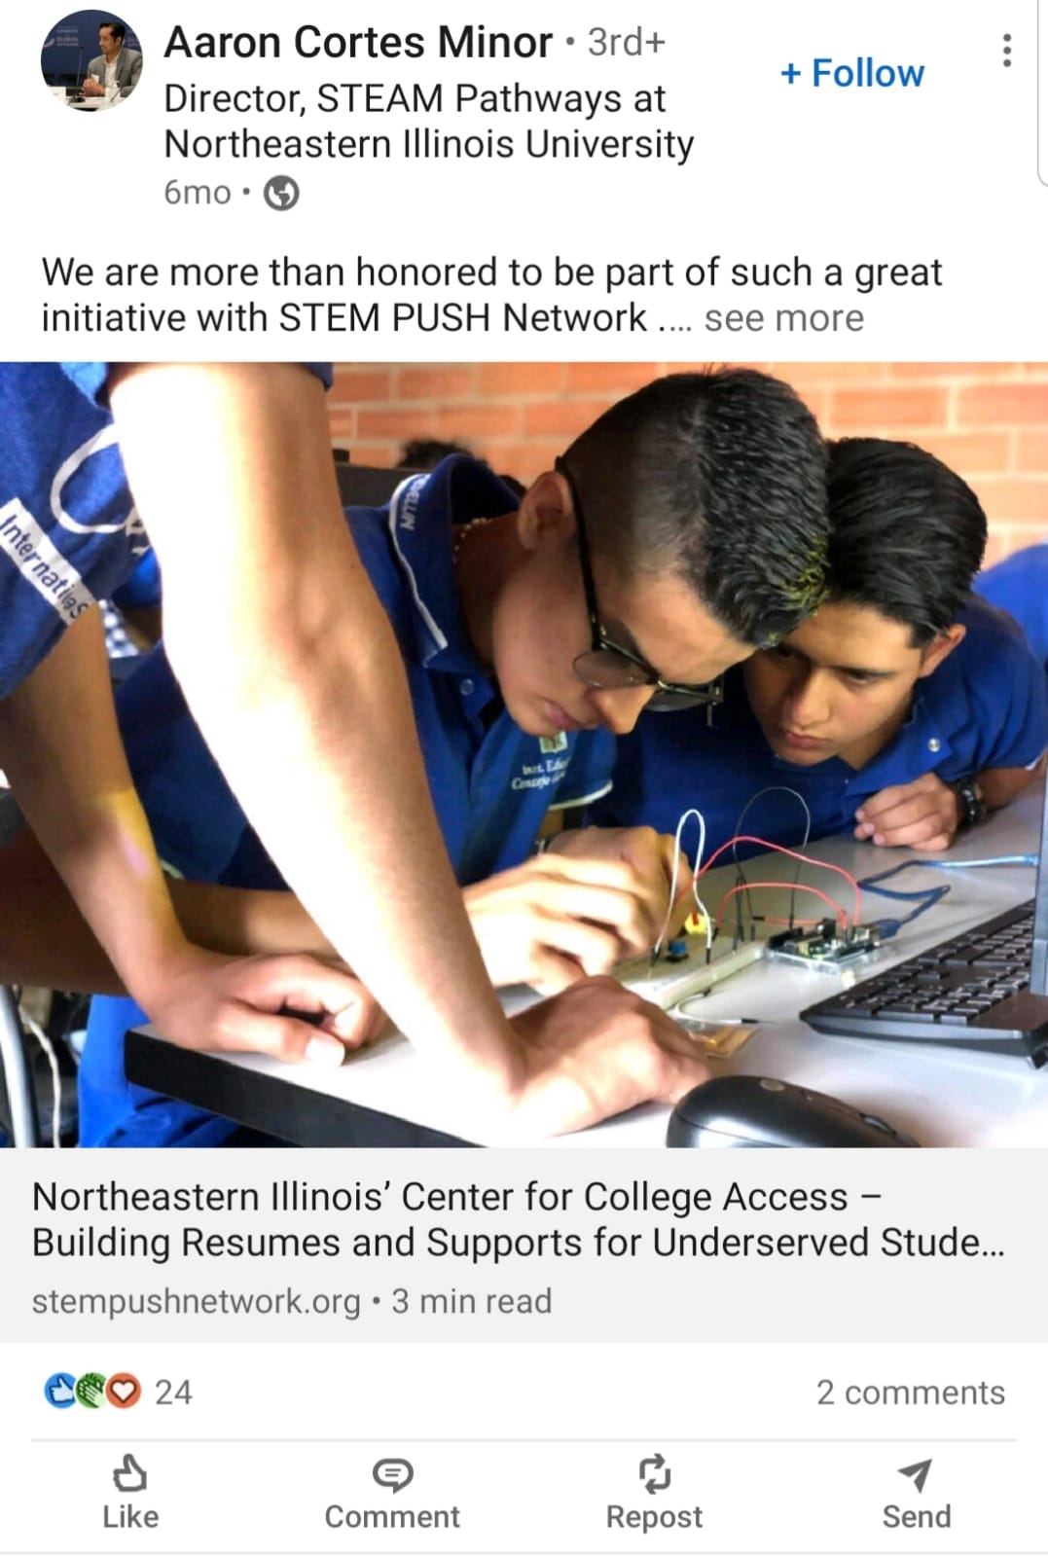

Aaron Cortes Minor is the author of the post.

The post states, "We are more than honored to be part of such a great initiative with STEM PUSH Network ."

The post received 24 reactions and received 2 comments.

LinkedIn Analysis:

* *Demonstrating awareness of the current discussions and challenges*: The research project uncovered a significant amount of discussion on the participation of women in STEM fields. It revealed contrasting viewpoints, with some individuals expressing concerns about the lack of female representation due to fewer girls pursuing computer science.
* *Highlighting relevant contributions and expertise*: Stephanie Espy, an active contributor mentioned in the research, regularly shares successful stories in STEM to inspire others. Moreover, she focuses on raising awareness about gender inequality in STEM. Referencing Stephanie Espy's contributions can demonstrate an understanding of the importance of role models and the desire to inspire and support others through shared success stories and addressing critical issues.
* *Showcasing support from external entities:* The research project revealed that different areas, such as Charlotte, and universities like Northern Illinois, are supporting the STEM PUSH initiative.
* *Addressing socioeconomic disparities in STEM education*: The research project revealed posts discussing the discrepancy between higher-income schools and low-income schools in terms of students' participation in STEM education.
* *Highlights*:
  + Jeremy Mellito posted PBL(Project based learning) and STEM based learning are the ones that will be in the future unlike the traditional teach-read-write-test
  + Bernard Akawsee posted the success story of Mwangala M by tagging #stem, which got the likes of 332 and 5 reposts

Sample Twitter tweet:

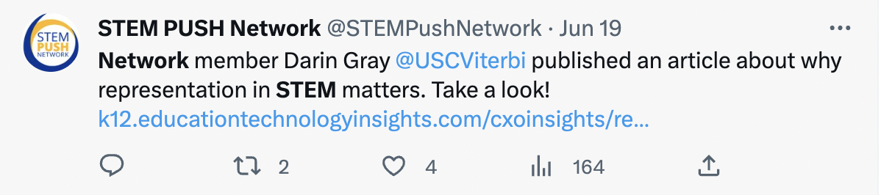

STEM PUSH Network is the author of the tweet

Network member Darin Gray … describes the description of the tweet

The tweet got 2 retweets, 4 likes and 164 views

Twitter Analysis:

* *Engagement and Expansion*: The STEM PUSH Network is actively seeking participants for its 3rd cohort, indicating a growing and engaged community. Expressing interest in joining the cohort demonstrates enthusiasm for being part of a network that supports underrepresented students in higher education.
* *Commitment to Communication*: The STEM PUSH Network's consistent monthly newsletters showcase their commitment to keeping members informed about the latest updates and opportunities. Highlighting the importance of effective communication and staying up-to-date with developments in STEM education can demonstrate alignment with the network's values.
* *Awareness of Challenges*: The Education Trust's page observation about the low enrollment in Advanced Placement STEM courses highlights an important challenge in the education system. Acknowledging this issue and expressing a willingness to contribute towards improving STEM access and participation can showcase a commitment to equity and inclusivity in education.
* *Advocacy for Sensible Immigration*: MrCopolo's post regarding the impact of sensible immigration policies on STEM education emphasizes the value of diverse perspectives and talent in the field. Expressing support for inclusive immigration policies that foster the growth and innovation of STEM fields can highlight a broader understanding of the importance of diverse talent and global collaboration.
* *Highlights*:
  + Mrcopolo posted a demand for an increase in sensible immigration, Without them, only 20,000 people would have graduated with Stem phds, which is less than half of the Chinese.
  + STEM PUSH Network page posted for PCPs to join for the 3rd cohort.

Sample Instagram Post:



The author of the post is asujbmshp

The post states that “Happy pi day”

The post got 32 likes

Instagram Analysis:

* *Active engagement in the STEM education community*: Our research project has identified pages like Remake Learning (@remakelearning) that actively promote discussions on STEM education. They regularly organize meetings on Twitter to facilitate knowledge exchange and collaboration among educators, researchers, and stakeholders. This highlights our commitment to being actively involved in the STEM education community and staying updated with the latest developments and conversations in the field.
* *Collaborative partnerships with reputable organizations*: Our findings indicate that Pitt Bio Outreach (@pittbiooutreach) expresses their satisfaction in working with the National Science Foundation (NSF). This showcases our ability to establish and maintain valuable partnerships with renowned organizations in the STEM domain.
* *Highlights*:
  + Remake Learning (@remakelearning) posted to join the meetings on Twitter for discussion on STEM education.

**Data Analysis**

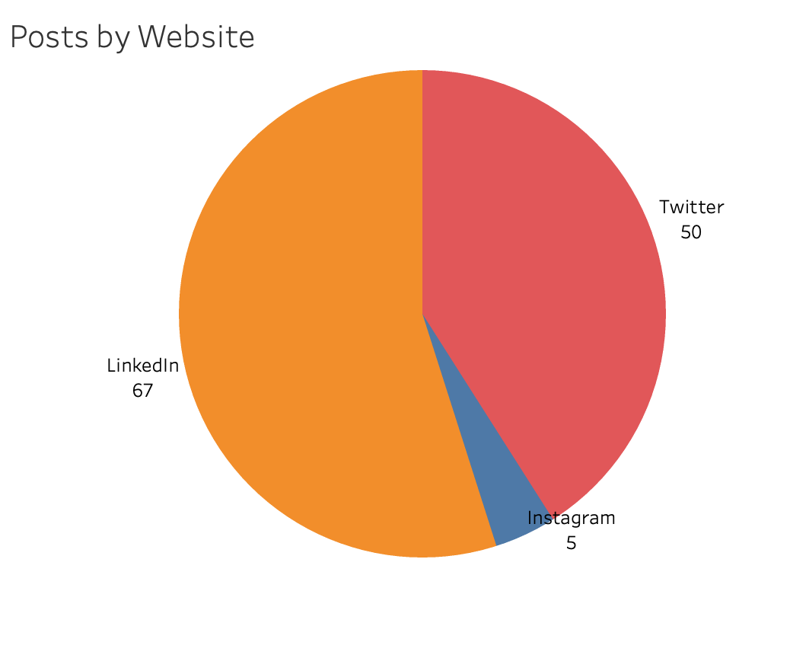

The LinkedIn website has the highest number of posts with 67, indicating it is the most active platform.

Instagram has the lowest number of posts with just 5, suggesting it is not as popular for posting compared to LinkedIn and Twitter.

Twitter falls in the middle with 50 tweets, indicating a moderate level of activity on the platform.

**1a**

*Diagram 1a*: Proportion of Posts across Social Media Platforms. Pie chart showing the distribution of posts across various social media websites.

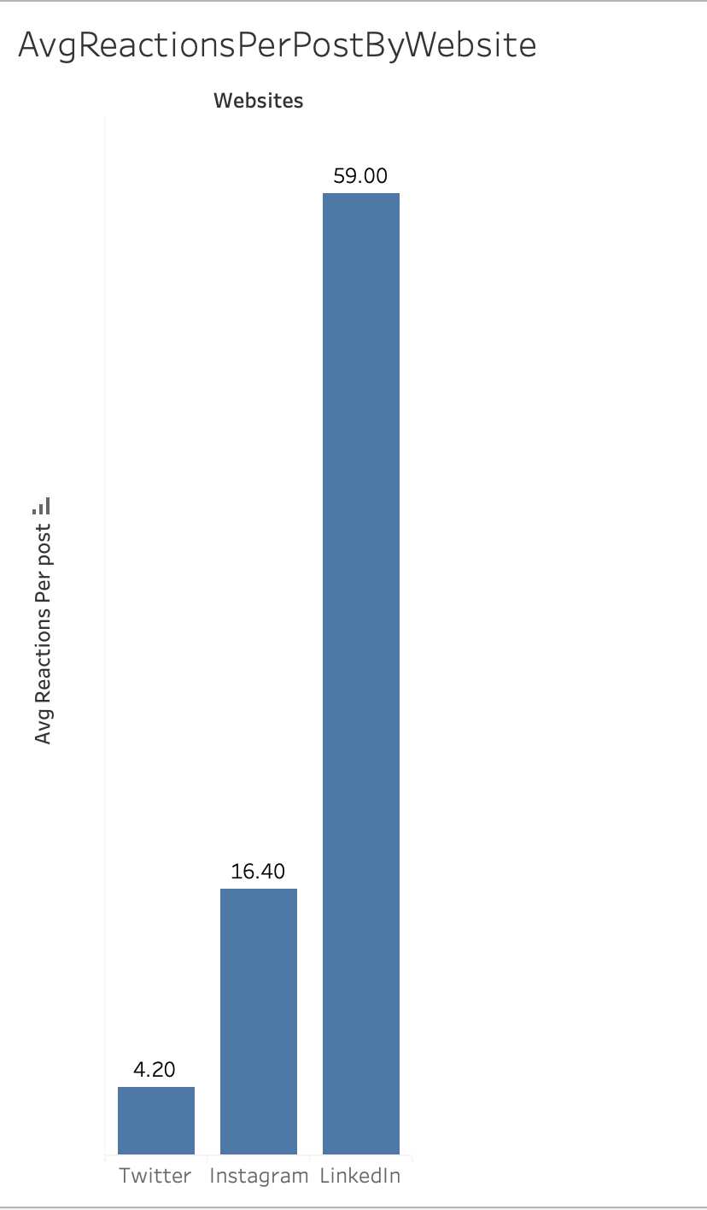

LinkedIn has the highest average reactions per post with 59, indicating that LinkedIn users tend to engage more with the content compared to the other platforms.

Instagram has a moderately high average reactions per post with 16.4, suggesting that this platform also sees a good level of engagement from its users.

Twitter has the lowest average reactions per post with 4.2, indicating that Twitter users tend to have lower engagement levels compared to LinkedIn and Instagram. **1b**

*Diagram 1b*: Bar chart showcasing average likes per post across different social media platforms.

**External Websites**

Below are the valuable insights from other websites, providing additional crucial information about the keywords.

* TikTok introduces a STEM-related content stream, highlighting the growing interest in STEM education and related hashtags. In fact, stem-related hashtags have received over 110 billion views to date. – social media today
* NASA's funding initiatives aim to support minority institutions in preparing students for STEM careers. – NASA
* Grants from organizations like the PSEG Foundation and Naval Research highlight efforts to expand STEM pathways and opportunities for underrepresented students. – Colorado

**Recommendation**

It is observed that the number of posts related to STEM education and its keywords on Instagram is significantly lower compared to other social media platforms. To enhance outreach and engagement, it is highly recommended to prioritize and expand the presence of STEM PUSH initiatives on Instagram.